Lab Report No 6

Understanding and implementing Artificial Neural Network
Artificial Intelligence



Submitted By:
[Huzaifa Shahbaz]
[21-CE-009]
[Aqsa Shah]
[21-CE-039]
Submitted to:
Engr. Hareem Khan
Dated:
8thApr,2025
Department of Computer Engineering,
HITEC University, Taxila

Example Task No 1:

Solution:
Brief description (3-5 lines)
Artificial Neural Network (ANN):
Artificial Neural Network (ANN) is an efficient computing system whose central theme is borrowed from the analogy of biological neural networks. ANNs are also named as “artificial neural systems,” or “parallel distributed processing systems,” or “connectionist systems.” ANN acquires a large collection of units that are interconnected in some pattern to allow communication between the units. These units, also referred to as nodes or neurons, are simple processors which operate in parallel. Every neuron relates to other neuron through a connection link. Each connection link is associated with a weight that has information about the input signal. This is the most useful information for neurons to solve a particular problem because the weight usually excites or inhibits the signal that is being communicated. Each neuron has an internal state, which is called an activation signal. Output signals, which are produced after combining the input signals and activation rule, may be sent to other units.
The code
import numpy as np
import pandas as pd
from sklearn.model_selection import train_test_split
from sklearn.preprocessing import StandardScaler
from tensorflow.keras.models import Sequential
from tensorflow.keras.layers import Dense
from sklearn.datasets import load_iris
from sklearn.metrics import accuracy_score
# Step 1: Load the Iris dataset
iris = load_iris()
X = iris.data # Features (4 features per sample)
y = iris.target # Target classes (3 classes)
# Step 2: Preprocess the data (use only two classes for binary classification)
# We will classify class 0 (Setosa) vs class 1 (Versicolor)
X = X[y != 2] # Remove class 2 (Virginica)
y = y[y != 2] # Remove class 2 (Virginica)
# Step 3: Split the data into training and testing sets
X_train, X_test, y_train, y_test = train_test_split(X, y, test_size=0.2, random_state=42)
# Step 4: Standardize the data (helpful for ANN performance)
scaler = StandardScaler()
X_train = scaler.fit_transform(X_train)
X_test = scaler.transform(X_test)
# Step 5: Build the ANN model
model = Sequential()
# Input layer and first hidden layer with 8 neurons and ReLU activation
model.add(Dense(units=8, input_dim=X_train.shape[1], activation='relu'))
# Output layer with 1 neuron and sigmoid activation (for binary classification)
model.add(Dense(units=1, activation='sigmoid'))
# Step 6: Compile the model
model.compile(loss='binary_crossentropy', # For binary classification
optimizer='adam', # Optimizer
metrics=['accuracy']) # Evaluation metric
# Step 7: Train the model
history = model.fit(X_train, y_train, epochs=50, batch_size=10, validation_split=0.2)
# Step 8: Evaluate the model
y_pred_prob = model.predict(X_test)
y_pred = (y_pred_prob > 0.5).astype(int) # Convert probabilities to binary predictions
# Calculate accuracy
accuracy = accuracy_score(y_test, y_pred)
print(f"Model Accuracy: {accuracy * 100:.2f}%")
# Optional: Plotting training history (loss and accuracy)
import matplotlib.pyplot as plt
plt.figure(figsize=(12, 6))
# Plotting loss
plt.subplot(1, 2, 1)
plt.plot(history.history['loss'], label='Training Loss')
plt.plot(history.history['val_loss'], label='Validation Loss')
plt.title('Loss during Training')
plt.xlabel('Epochs')
plt.ylabel('Loss')
plt.legend()
# Plotting accuracy
plt.subplot(1, 2, 2)
plt.plot(history.history['accuracy'], label='Training Accuracy')
plt.plot(history.history['val_accuracy'], label='Validation Accuracy')
plt.title('Accuracy during Training')
plt.xlabel('Epochs')
plt.ylabel('Accuracy')
plt.legend()
plt.show()
The results (Screenshot)
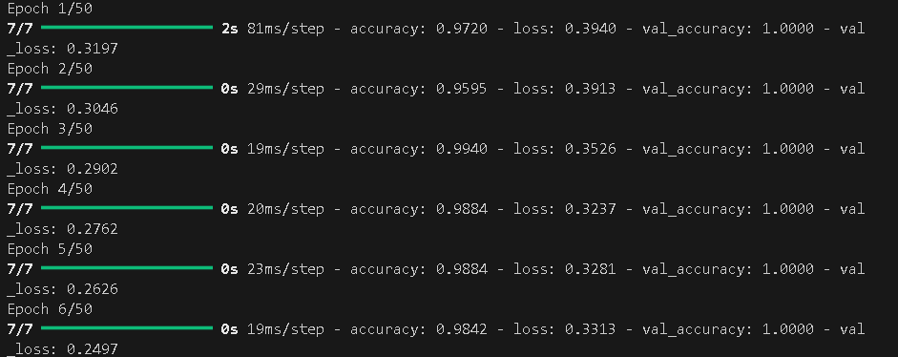
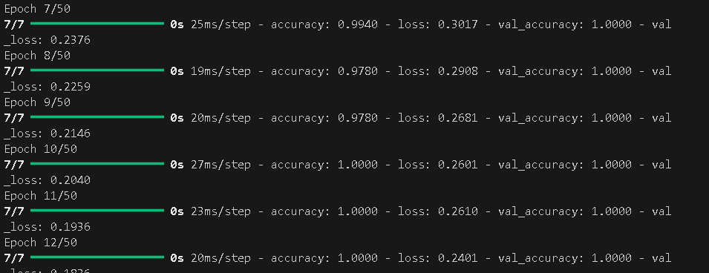
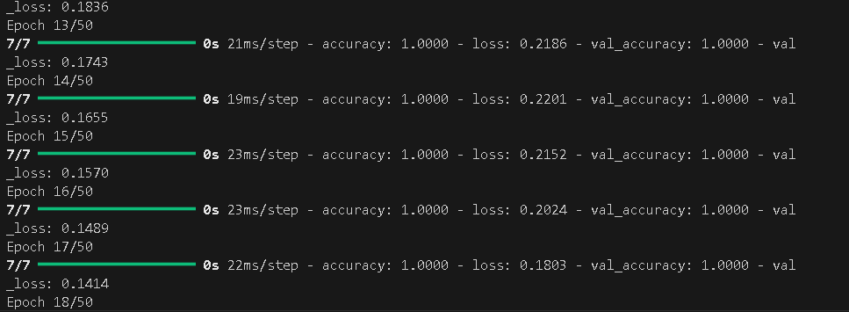
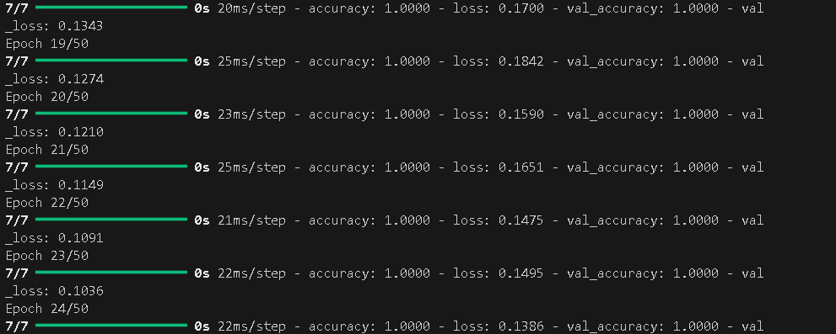
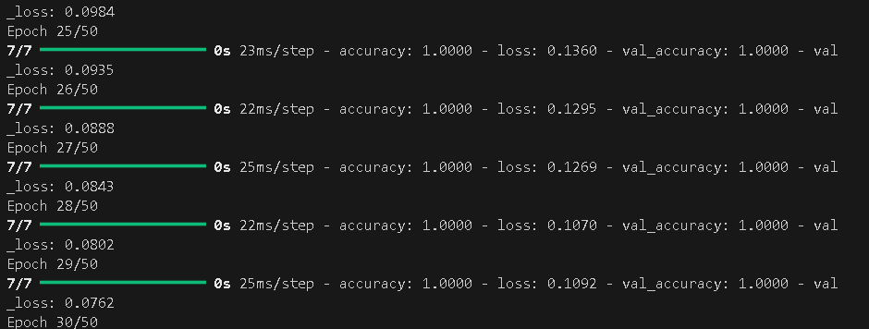
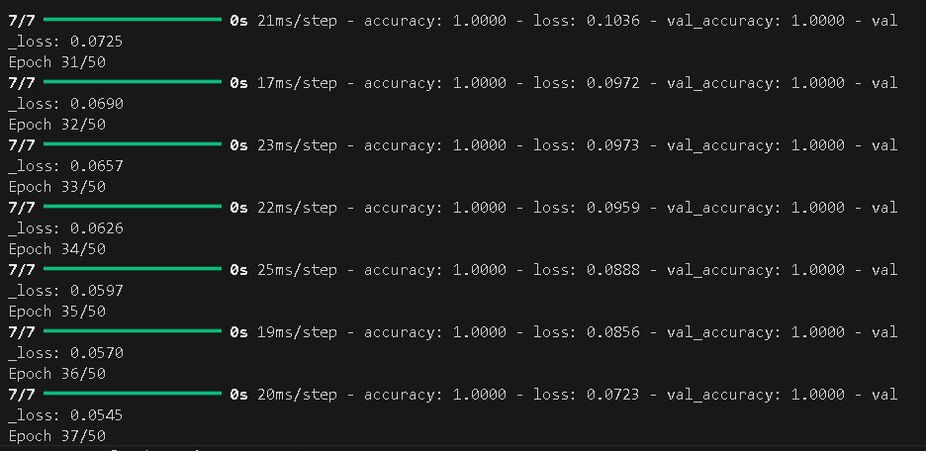
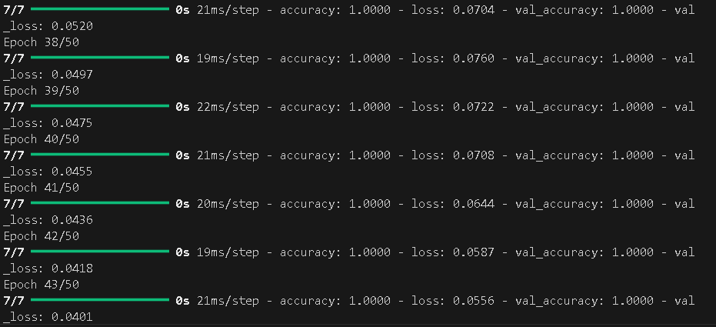
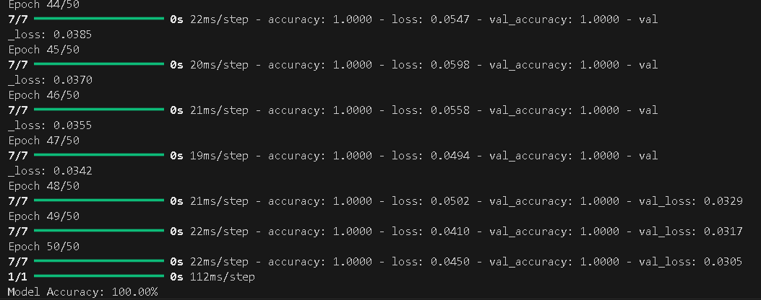
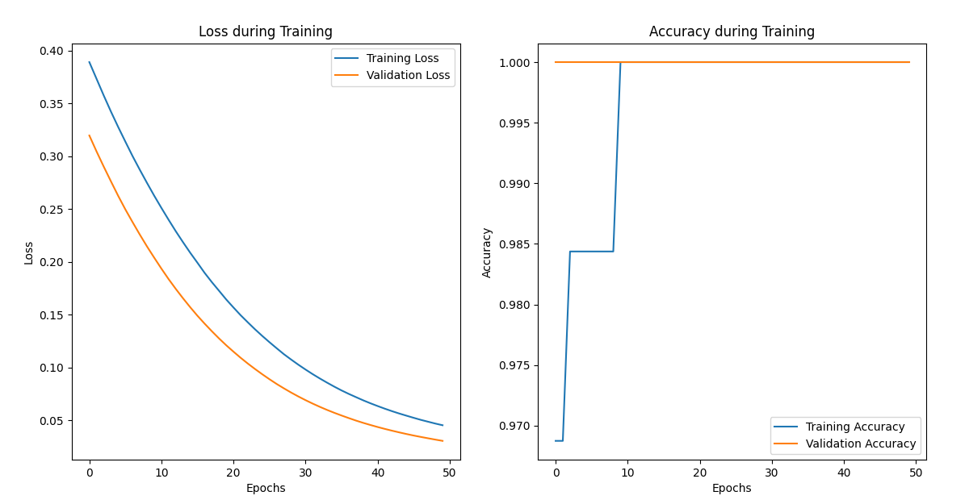

Lab Task No 1(i):

Solution:
Brief description (3-5 lines)
Build a Simple ANN for Binary Classification:
Use a binary classification dataset (e.g., Iris dataset, classify Setosa vs. Virginica).
The code
import numpy as np
import pandas as pd
import matplotlib.pyplot as plt
from sklearn import datasets
from sklearn.model_selection import train_test_split
from sklearn.preprocessing import StandardScaler
from sklearn.metrics import classification_report
from tensorflow.keras.models import Sequential
from tensorflow.keras.layers import Dense
from tensorflow.keras.optimizers import Adam
# Load the Iris dataset
iris = datasets.load_iris()
X = iris.data
y = iris.target
# Filter only Setosa (0) and Virginica (2)
binary_filter = (y == 0) | (y == 2)
X = X[binary_filter]
y = y[binary_filter]
# Convert labels to 0 and 1
y = (y == 2).astype(int) # Setosa = 0, Virginica = 1
# Train-test split
X_train, X_test, y_train, y_test = train_test_split(X, y, test_size=0.2, random_state=42)
# Feature scaling
scaler = StandardScaler()
X_train_scaled = scaler.fit_transform(X_train)
X_test_scaled = scaler.transform(X_test)
# Build ANN model
model = Sequential()
model.add(Dense(10, input_shape=(4,), activation='relu'))
model.add(Dense(1, activation='sigmoid'))
# Compile the model
model.compile(optimizer=Adam(learning_rate=0.01), loss='binary_crossentropy', metrics=['accuracy'])
# Train the model
history = model.fit(X_train_scaled, y_train, epochs=50, validation_data=(X_test_scaled, y_test), verbose=0)
# Evaluate the model
loss, accuracy = model.evaluate(X_test_scaled, y_test)
print(f"Test Accuracy: {accuracy:.2f}")
# Classification report
y_pred = (model.predict(X_test_scaled) > 0.5).astype("int32")
print("\nClassification Report:\n", classification_report(y_test, y_pred))
# Plot training history
plt.plot(history.history['accuracy'], label='Train Accuracy')
plt.plot(history.history['val_accuracy'], label='Validation Accuracy')
plt.title('Model Accuracy over Epochs')
plt.xlabel('Epochs')
plt.ylabel('Accuracy')
plt.legend()
plt.grid(True)
plt.tight_layout()
plt.show()
The results (Screenshot)
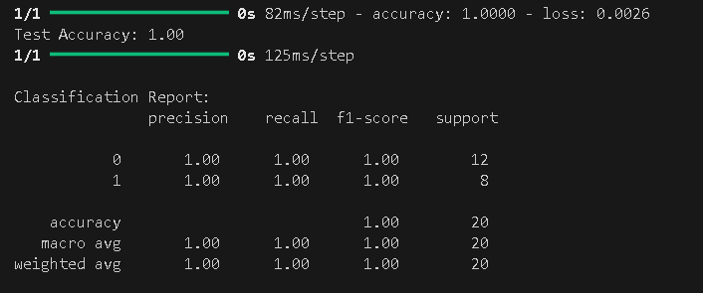
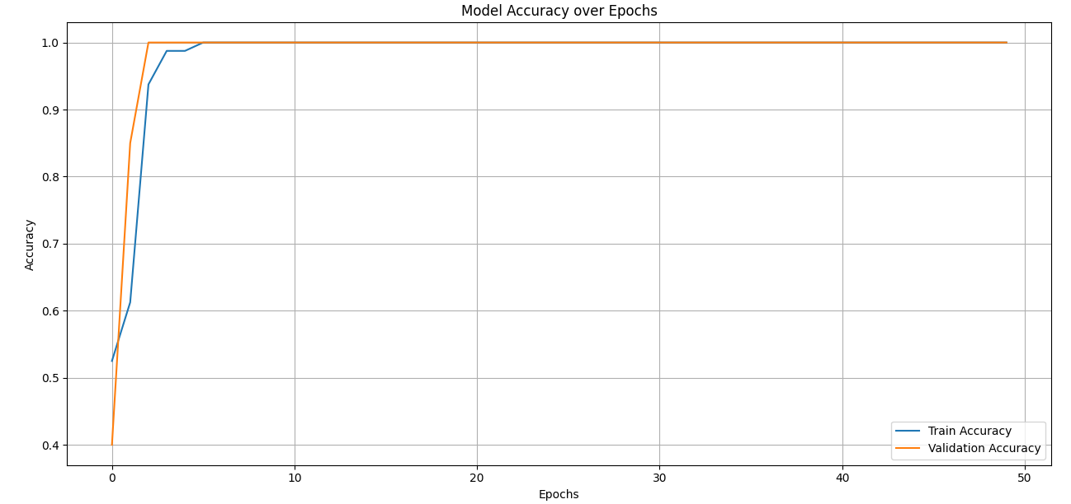

Lab Task No 1(ii):

Solution:
Brief description (3-5 lines)
Build a Simple ANN for Binary Classification
Build an ANN with:
▪ Input Layer: 4 neurons (one for each feature).
▪ Hidden Layer: 8 neurons with ReLU activation.
▪ Output Layer: 1 neuron with sigmoid activation for binary classification.
The code
import numpy as np
import matplotlib.pyplot as plt
from sklearn.datasets import make_classification
from sklearn.model_selection import train_test_split
from sklearn.preprocessing import StandardScaler
from tensorflow.keras.models import Sequential
from tensorflow.keras.layers import Dense
from tensorflow.keras.utils import plot_model
import tensorflow as tf
# 1. Generate a synthetic binary classification dataset
X, y = make_classification(n_samples=1000, n_features=4, n_informative=3, n_redundant=0,n_clusters_per_class=1, random_state=42)
# 2. Split into training and testing data
X_train, X_test, y_train, y_test = train_test_split(X, y, test_size=0.2, random_state=42)
# 3. Standardize the feature values
scaler = StandardScaler()
X_train = scaler.fit_transform(X_train)
X_test = scaler.transform(X_test)
# 4. Build the ANN model
model = Sequential([
Dense(8, input_shape=(4,), activation='relu'), # Hidden Layer
Dense(1, activation='sigmoid') # Output Layer
])
# 5. Compile the model
model.compile(optimizer='adam',
loss='binary_crossentropy',
metrics=['accuracy'])

# 6. Train the model
history = model.fit(X_train, y_train, epochs=50, batch_size=16, validation_split=0.2)
# 7. Evaluate the model
loss, accuracy = model.evaluate(X_test, y_test)
print(f'\nTest Accuracy: {accuracy:.4f}')
plt.figure(figsize=(12, 5))
plt.subplot(1, 2, 1)
plt.plot(history.history['accuracy'], label='Train Accuracy')
plt.plot(history.history['val_accuracy'], label='Val Accuracy')
plt.title('Model Accuracy')
plt.xlabel('Epoch')
plt.ylabel('Accuracy')
plt.legend()
plt.subplot(1, 2, 2)
plt.plot(history.history['loss'], label='Train Loss')
plt.plot(history.history['val_loss'], label='Val Loss')
plt.title('Model Loss')
plt.xlabel('Epoch')
plt.ylabel('Loss')
plt.legend()
plt.tight_layout()
plt.show()
plot_model(model, to_file='model_architecture.png', show_shapes=True, show_layer_names=True)
The results (Screenshot)
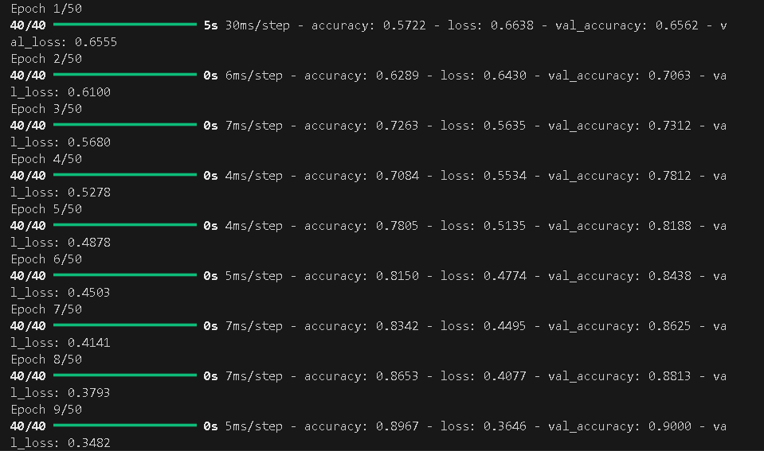
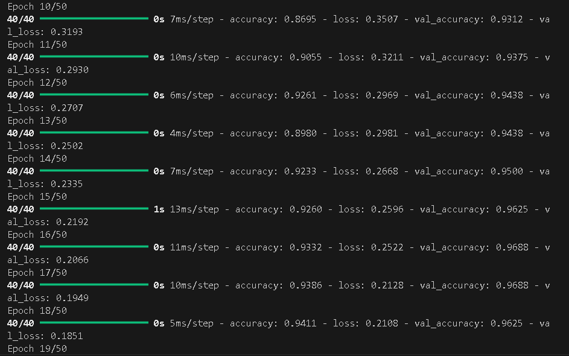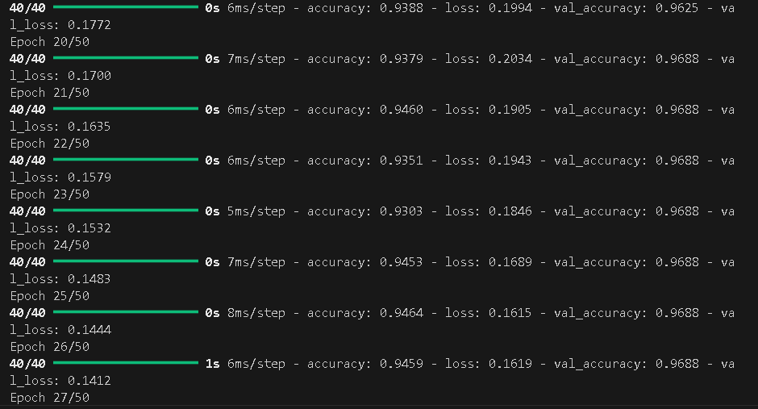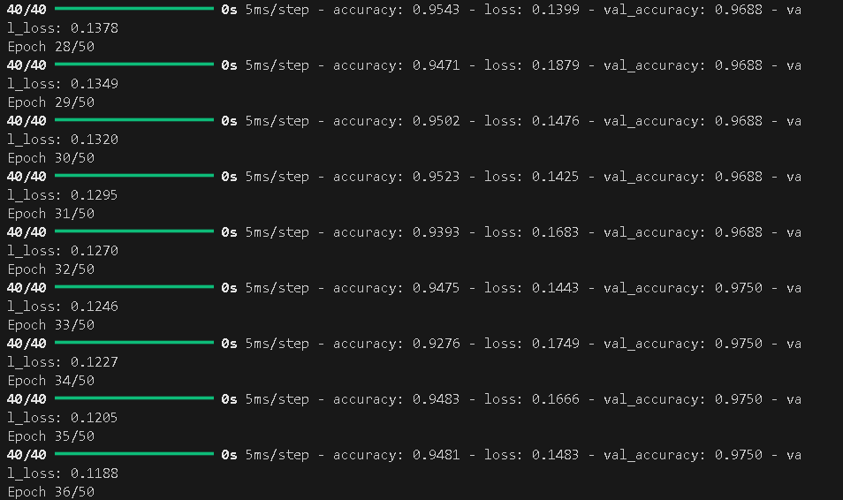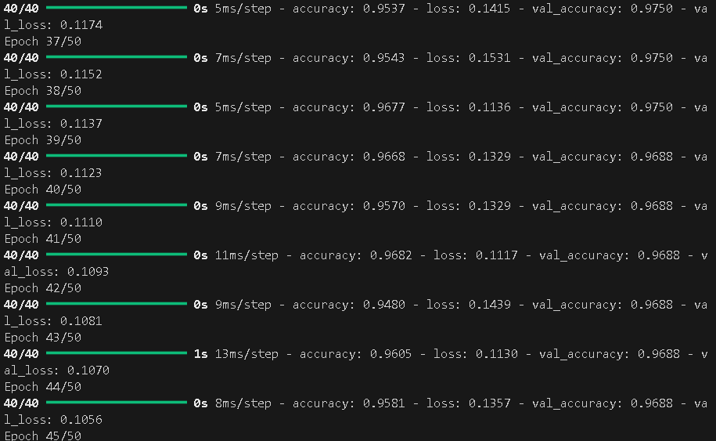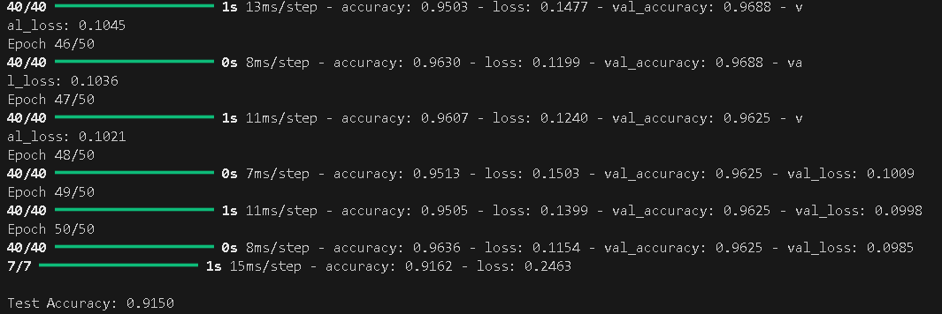
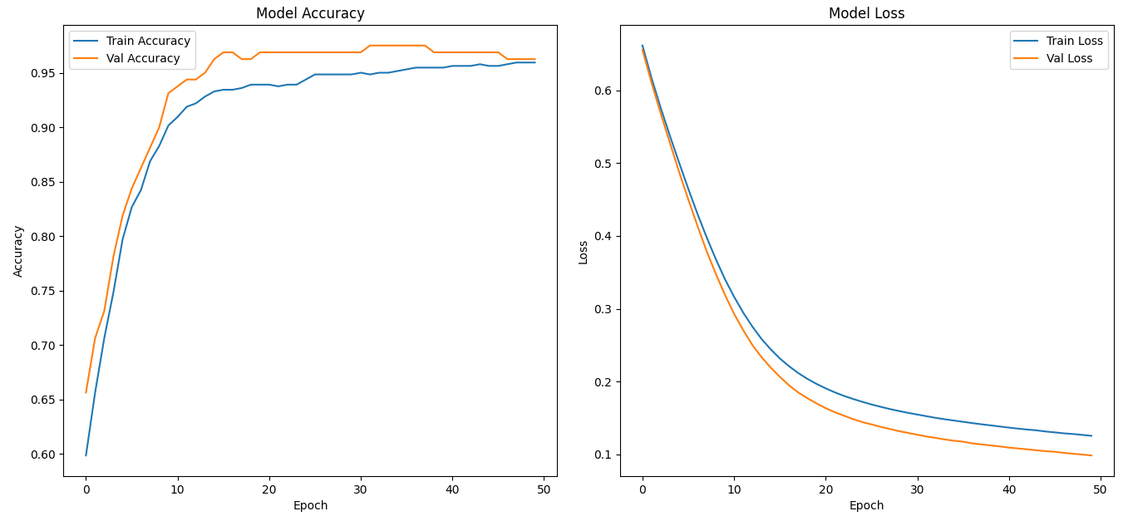
Lab Task No 1(iii):

Solution:
Brief description (3-5 lines)
Build a Simple ANN for Binary Classification
Use binary cross-entropy as the loss function and adam optimizer.
The code
import numpy as np
import matplotlib.pyplot as plt
from tensorflow.keras.models import Sequential
from tensorflow.keras.layers import Dense
from tensorflow.keras.optimizers import Adam
from sklearn.model_selection import train_test_split
from sklearn.datasets import make_classification
# Step 1: Generate Synthetic Binary Classification Data
X, y = make_classification(n_samples=1000, n_features=10, n_classes=2,n_informative=5, n_redundant=2, random_state=1)
# Step 2: Split into training and testing sets
X_train, X_test, y_train, y_test = train_test_split(X, y, test_size=0.2, random_state=42)
# Step 3: Build ANN Model
model = Sequential([
Dense(16, activation='relu', input_shape=(X.shape[1],)),
Dense(8, activation='relu'),
Dense(1, activation='sigmoid') # Output layer for binary classification
])
# Step 4: Compile the model
model.compile(optimizer=Adam(), loss='binary_crossentropy', metrics=['accuracy'])
# Step 5: Train the model
history = model.fit(X_train, y_train, validation_data=(X_test, y_test),epochs=30, batch_size=32, verbose=1)
# Step 6: Plot accuracy and loss
plt.figure(figsize=(12, 5))
# Accuracy Plot
plt.subplot(1, 2, 1)
plt.plot(history.history['accuracy'], label='Train Accuracy', marker='o')
plt.plot(history.history['val_accuracy'], label='Validation Accuracy', marker='x')
plt.title('Model Accuracy')
plt.xlabel('Epoch')
plt.ylabel('Accuracy')
plt.grid(True)
plt.legend()
# Loss Plot
plt.subplot(1, 2, 2)
plt.plot(history.history['loss'], label='Train Loss', marker='o')
plt.plot(history.history['val_loss'], label='Validation Loss', marker='x')
plt.title('Model Loss')
plt.xlabel('Epoch')
plt.ylabel('Loss')
plt.grid(True)
plt.legend()
plt.tight_layout()
plt.show()
The results (Screenshot)
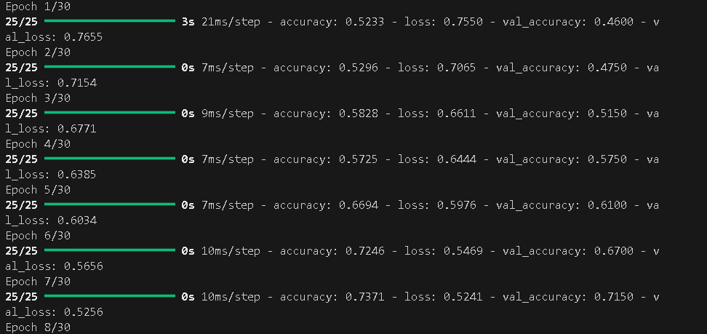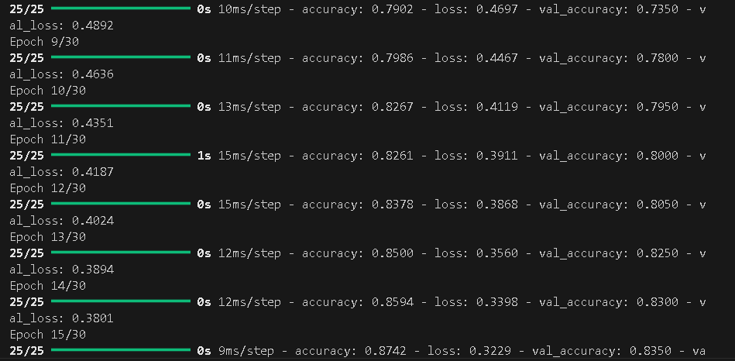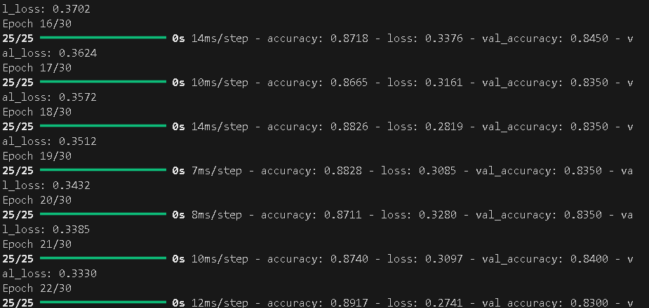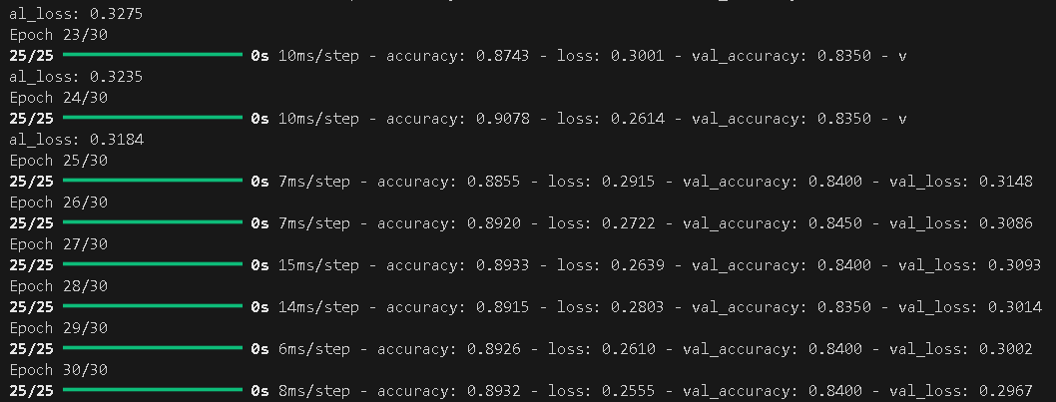
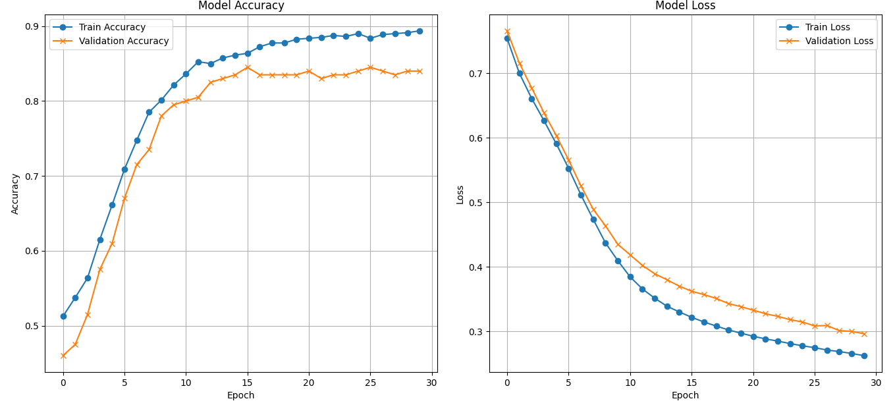
Conclusion
In conclusion, Artificial Neural Networks (ANNs) are crucial in modern AI applications due to their adaptability and accuracy. They mimic human learning, enhance decision-making across domains, and enable engineers to innovate intelligent systems for real-world challenges, making them essential in AI applications.

